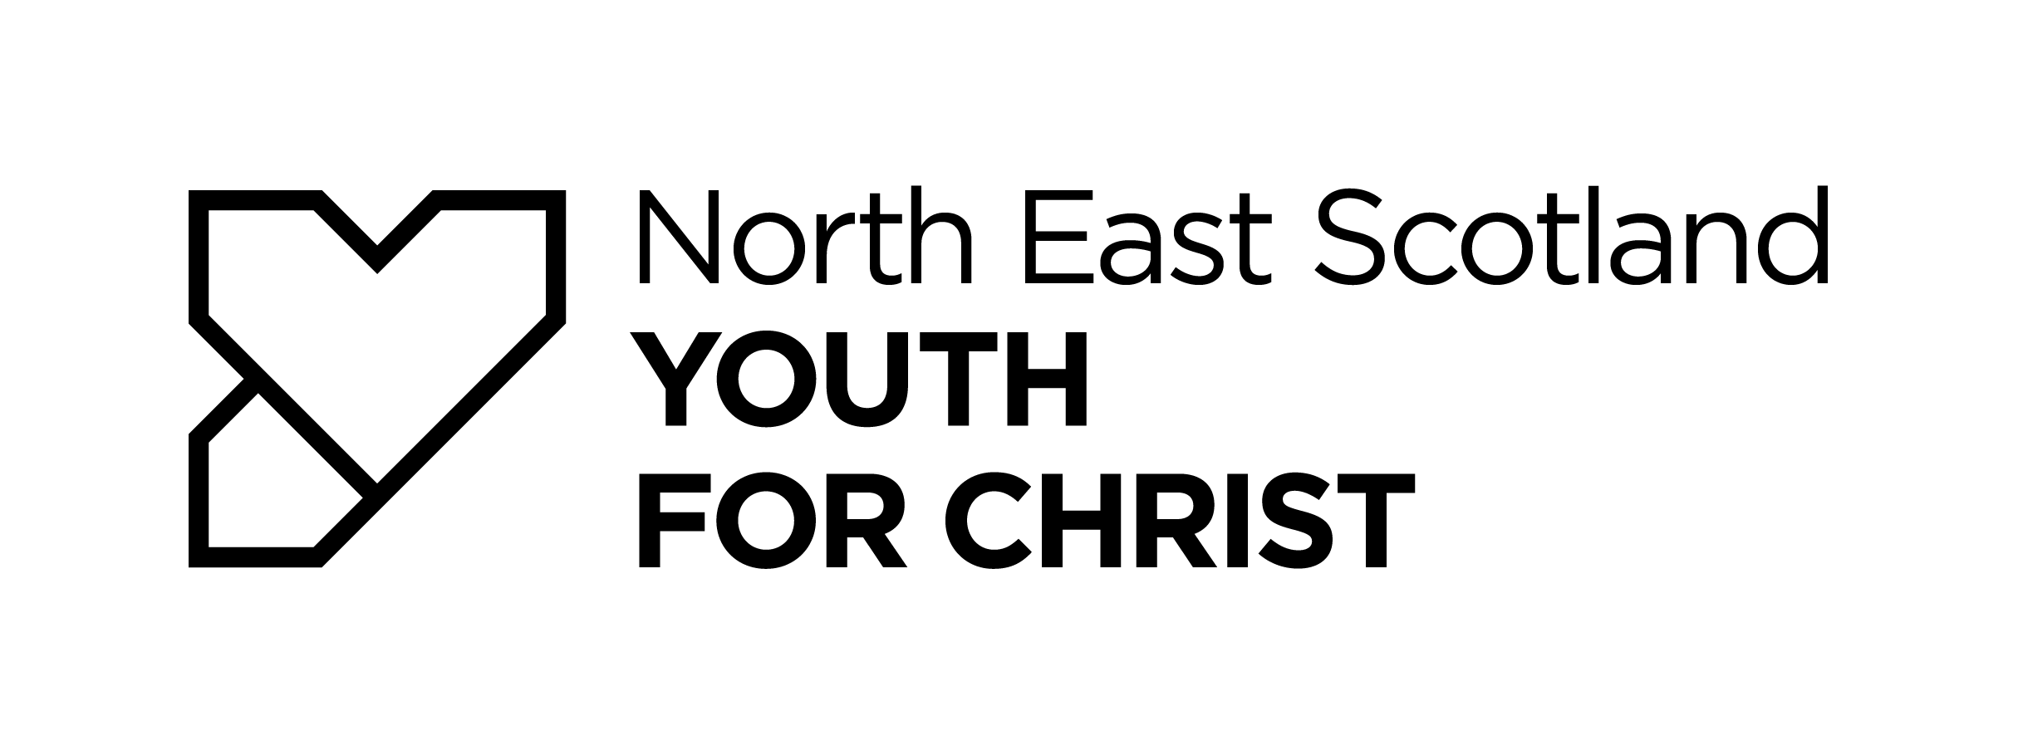
GIFT AID DECLARATION

Boost your donation by 25p of Gift Aid for every £1 you donate. Gift Aid is reclaimed by the charity from the tax you pay for the current tax year.

Your address is needed to identify you as a current UK taxpayer.

I want to Gift Aid my donation of £ ________ and any donations I make in the future, or have made in the past 4 years to:

NORTH EAST SCOTLAND YOUTH FOR CHRIST

I am a UK taxpayer and understand that if I pay less Income Tax and/or Capital Gains Tax than the amount of Gift Aid claimed on all my donations in that tax year it is my responsibility to pay any difference.

My Details

Title ____________ First name or initial(s) ________________________________

Surname _____________________________________________________________________

Full Home address _____________________________________________________________ _

____________________________________________________________________________

Postcode __________________________

Date ___________________________________

Please notify the charity if you:
• want to cancel this declaration
• change your name or home address
• no longer pay sufficient tax on your income and/or capital gains

If you pay Income Tax at the higher or additional rate and want to receive the additional tax relief due to you, you must include all your Gift Aid donations on your Self-Assessment tax return or ask HM Revenue and Customs to adjust your tax code.

